 | EUROPEAN COMMISSION  DIRECTORATE-GENERAL  INFORMATICS  Information Systems Directorate

European Commission
E-TrustEx GUI Specification: Generate New Notification Template

Date: | 22/05/2017
Version: | 0.002
Authors: | Anamaria BATRINU
Revised by:
Approved by:
Public:
Reference Number:
TABLE OF CONTENTS
1. Description 3
2. E-mail Template 3
3. Information Mapping 3

Document History

Version | Date | Comment | Modified Pages
0.001 | 22/05/2017 | BATRIAN (JIRA ETX-2072): First draft | All
0.002 | 04/08/2017 | BATRIAN | Added note: Section 3 Information Mapping

Description
This Specification describes the new e-mail template used for Web Payload-based emails (Section 2 E-mail Template) and the information mapping corresponding to it (Section 3 Information Mapping).

E-mail Template
The new e-mail template shall contain the following information:
- The title
- The available linguistic versions
- File under subsidiary check (conditional display)

Please use the template in Figure 1 as reference. The mapping is described in section
Figure 1 - E-mail Template
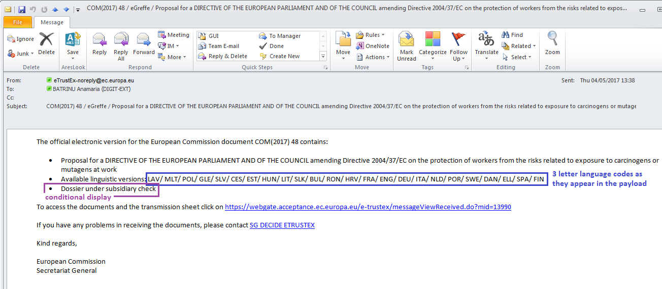

Information Mapping
NOTE: From the business point of view there can only be one ACT.
The mapping of the information to display in the e-mail template is described in the below table:
Information | xPath (xmlns:ns3="urn:eu:ec:cm:common:extensions:v11") | Comments/Remarks
Title | - "transmission/workflow/extension/ns3:short_title"  - If the element at point 1 does not exist or contains an empty value: "//work[extension/ns3:category="ACT"]/extension/ns3:summary_title" | For point 1:  - use always when it is available.  For point 2:  - there is maximum one event_legal per transmission for the EC transmission  - "procedure_interinstitutional" is not always present. If not, the works are in the "workflow"  - The element "work/extension/ns3:category" is used to select the work that is the "main document"
Available linguistic versions | "//work[extension/ns3:category="ACT"]/expression[manifestation]/language" | - The 3 char code follows the ISO-639-2 standard.  - Expression without manifestation means a linguistic version not yet sent  - Expression with manifestation means that the linguistic version was already sent. It does not mean that the sending is done in the current transmission. To know if the linguistic version is sent in the current transmission, you need to check if there is a file in the current transmission, with the name corresponding to the value of the element reference_manifestation.
Dossier under subsidiary check | "transmission/procedure_interinstitutional/extension/ns3:subsidiarity_proportionality_application/ns3:competence_type" | This information will be present only if the "ns3:subsidiarity_proportionality_application" exists and "ns3:subsidiarity_proportionality_application/ns3:competence" = "SHARED"

